**Project Design Phase-II**

**Data Flow Diagram & User Stories**

|  |  |
| --- | --- |
| Date | 31 January 2025 |
| Team ID |  |
| Project Name |  |
| Maximum Marks | 4 Marks |

**Data Flow Diagrams:**

A Data Flow Diagram (DFD) is a traditional visual representation of the information flows within a system. A neat and clear DFD can depict the right amount of the system requirement graphically. It shows how data enters and leaves the system, what changes the information, and where data is stored.



**Example:** [**(Simplified)**](https://developer.ibm.com/patterns/visualize-unstructured-text/)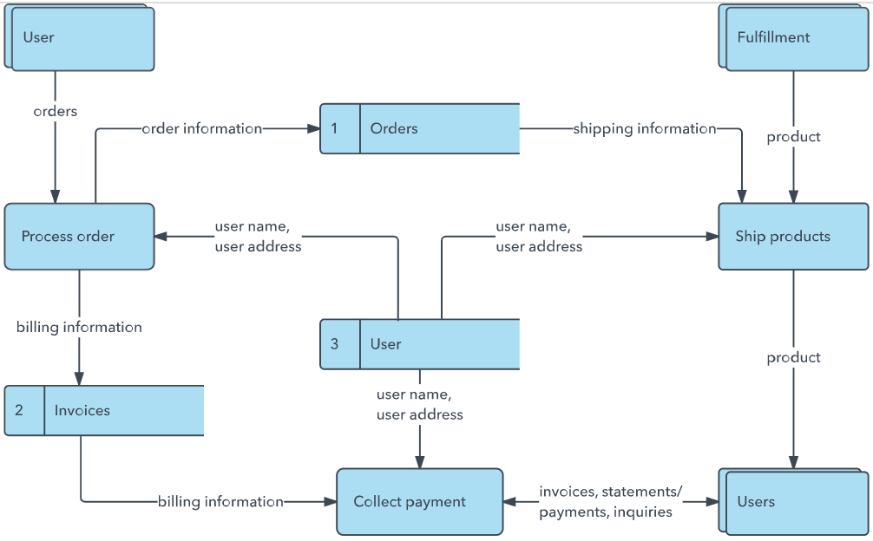

**User Stories**

Use the below template to list all the user stories for the product.

| **User Type** | **Functional Requirement (Epic)** | **User Story Number** | **User Story / Task** | **Acceptance Criteria** | **Priority & Release** | **User Type** |
| --- | --- | --- | --- | --- | --- | --- |
| Student (Web user) | Registration | USN-1 | As a student, I can register with my email and password. | I can access my dashboard after registration. | High / Sprint-1 | Student (Web user) |
| Student (Web user) | Registration | USN-2 | As a student, I receive an email confirmation after registering. | I can confirm my email via link. | High / Sprint-1 | Student (Web user) |
| Student (Web user) | Registration | USN-3 | As a student, I can register using my Gmail account. | I can login via Google and see my courses. | Medium / Sprint-1 | Student (Web user) |
| Student (Web user) | Login | USN-4 | As a student, I can log in using email and password. | I can log in and access quizzes. | High / Sprint-1 | Student (Web user) |
| Student (Web user) | Quiz Interaction | USN-5 | As a student, I can take a quiz generated by AI. | Quiz loads with topic-aligned questions. | High / Sprint-2 | Student (Web user) |
| Student (Web user) | Feedback | USN-6 | As a student, I can receive instant feedback after submission. | I receive my score and explanations. | High / Sprint-2 | Student (Web user) |
| Educator | Dashboard Access | USN-7 | As an educator, I can view performance analytics for each student. | Performance graphs and topic mastery visible. | High / Sprint-2 | Educator |
| Educator | User Management | USN-8 | As an educator, I can filter students based on progress. | I can shortlist underperforming students. | Medium / Sprint-3 | Educator |
| Admin | Role Management | USN-9 | As an admin, I can assign and manage user roles. | Users have correct access privileges. | High / Sprint-3 | Admin |
| Admin | System Monitoring | USN-10 | As an admin, I can monitor API usage and service uptime. | I see real-time server stats and logs. | Medium / Sprint-4 | Admin |
| User Type | Functional Requirement (Epic) | User Story Number | User Story / Task | Acceptance Criteria | Priority & Release | User Type |
| Student (Web user) | Registration | USN-1 | As a student, I can register with my email and password. | I can access my dashboard after registration. | High / Sprint-1 | Student (Web user) |